Week 3 – Python, Pandas & Exploratory Data Analysis
Final Project: Sales Data Cleaning, EDA & Business Insights
Data Analytics Internship — Day 5: Weekly Project & Revision

1. Project Overview
This report covers my Week 3 final project, which combines everything learned across the week — Python fundamentals, NumPy/Pandas, data cleaning, and exploratory data analysis (EDA) — into a single end-to-end pipeline: loading raw messy sales data, cleaning it, analyzing it statistically, visualizing it, and drawing business insights from the results.

Pipeline
- Load raw data → 14 records with missing values, a duplicate row, inconsistent text, mixed date formats, a negative price, and a quantity outlier
- Clean data using a reusable clean_sales_data() function
- Explore cleaned data with descriptive statistics and correlation analysis
- Visualize results with a bar chart, histogram, and correlation heatmap
- Summarize findings as business insights

2. Data Cleaning Summary
The raw dataset contained 14 rows with several data quality issues: 3 missing values (quantity, price, and city each had one), 1 exact duplicate order, inconsistent city/category text (e.g. "lahore", "LAHORE", "Lahore"), order dates written in three different formats, one negative price, and one unrealistic quantity outlier (999 units). After cleaning, the dataset was reduced to 13 valid, standardized records with no missing values and no duplicates.
Metric | Before Cleaning | After Cleaning
Total records | 14 | 13
Missing values | 3 (quantity, price, city) | 0
Duplicate rows | 1 | 0
Text formatting | Inconsistent (e.g. lahore/LAHORE) | Standardized (Title Case)
Date format | Mixed (DD/MM/YYYY, DD-MM-YYYY, YYYY-MM-DD) | Uniform datetime

3. Descriptive Statistics
Summary statistics on the cleaned dataset (13 records):
Statistic | Quantity | Price (Rs.) | Total Amount (Rs.)
Mean | 1.38 | 28,777.78 | 30,726.50
Median (50%) | 1.00 | 3,000.00 | 4,500.00
Std. Deviation | 0.65 | 36,133.71 | 35,808.67
Min | 1.00 | 833.33 | 1,277.78
Max | 3.00 | 80,000.00 | 80,000.00

The large gap between the median price (Rs. 3,000) and the mean price (Rs. 28,777.78) shows the price data is right-skewed — a small number of high-value items (laptops and monitors) pull the average well above what a typical order looks like.

4. Correlation Analysis
Correlation between price, quantity, and total amount:
 | Price | Quantity | Total Amount
Price | 1.00 | -0.42 | 0.99
Quantity | -0.42 | 1.00 | -0.36
Total Amount | 0.99 | -0.36 | 1.00

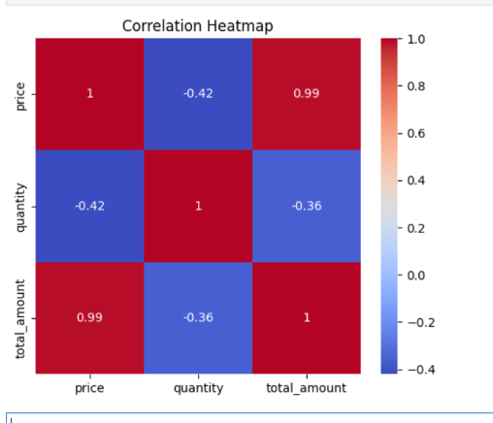
Price and total amount are very strongly correlated (0.99), which makes sense since total amount is derived directly from price. Interestingly, price and quantity show a moderate negative correlation (-0.42) — customers tend to buy more units of cheaper items (like mice and keyboards) and fewer units of expensive items (like laptops).

5. Visualizations

5.1 Total Sales by Category
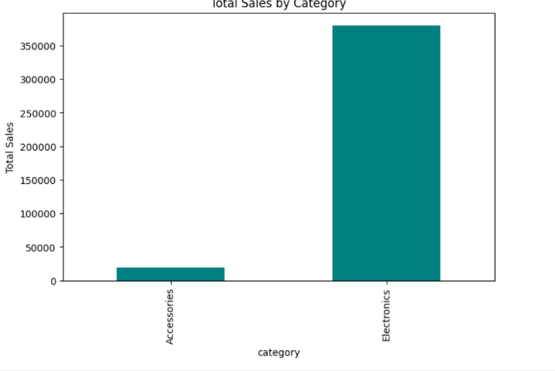
Electronics generated roughly Rs. 380,000 in total sales, compared to about Rs. 19,444 for Accessories — Electronics accounts for the large majority of revenue despite Accessories likely having more individual transactions.

5.2 Price Distribution
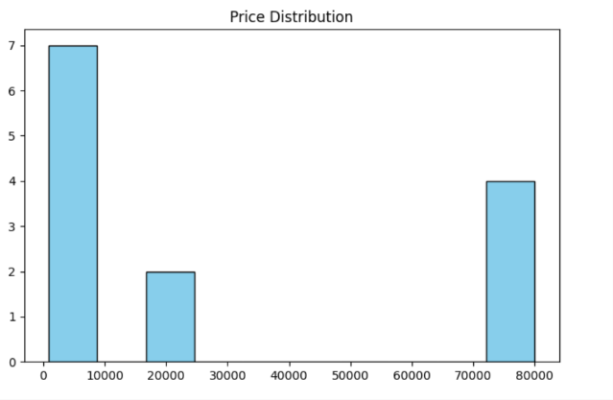
The price distribution is clearly bimodal: most orders (7 of 13) fall in the Rs. 0–10,000 range (accessories like mice and keyboards), while a second cluster of 4 orders sits in the Rs. 70,000–80,000 range (laptops), with very few orders in between. This gap reflects two distinct product tiers rather than a continuous price range.

6. Business Insights
- Electronics is the dominant revenue category (~Rs. 380,000 vs ~Rs. 19,444 for Accessories) — nearly 95% of total revenue — even though it likely represents fewer individual orders. The business is heavily dependent on high-ticket Electronics sales.
- There is a moderate negative correlation between price and quantity (-0.42): customers buy low-cost accessories in bulk but purchase electronics one at a time. This suggests Accessories could be a good candidate for volume-based promotions, while Electronics may benefit more from higher per-unit margins.
- The price distribution shows two distinct clusters (cheap accessories vs. expensive electronics) with almost nothing in between — there may be an opportunity to introduce a mid-range product tier (Rs. 20,000–50,000) to capture customers between these two segments.
- The original raw data required meaningful cleanup before analysis (missing values, a duplicate order, a negative price, and a 999-unit outlier order) — this reinforces that data cleaning is a necessary first step before any statistics or visualizations can be trusted.

7. Conclusion
This project brought together the full Week 3 toolkit — Python fundamentals, NumPy/Pandas, data cleaning, and exploratory data analysis — into one working pipeline that goes from raw, messy data to a set of concrete business insights. The strong price–total amount correlation, the bimodal price distribution, and Electronics' dominant share of revenue were the clearest patterns to emerge, and each points toward a specific, actionable next step for the business.

